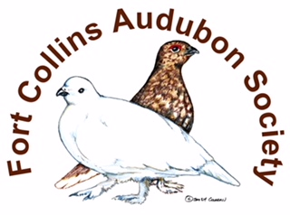
  - FORT COLLINS AUDUBON SOCIETY

  - Alex Cringan Memorial Scholarship Fund

The mission of the Fort Collins Audubon society is to promote the appreciation, conservation, and restoration of ecosystems focusing on birds and other wildlife – through education, participation, stewardship, and advocacy.
The Fort Collins Audubon Society has a scholarship for interested teachers and students to advance their knowledge of birds and conservation. Please read the scholarship application carefully for the selection criteria and send your completed application to:
FCAS Attn. Scholarship Committee
PO Box 271968
Fort Collins, Co 80527-1968
The purpose of the Alex Cringan Memorial fund is to provide financial assistance to educators or students involved in a project teaching or researching nature resources so they may enhance their skills and share their knowledge with others.
- Examples of projects are a training or workshop, a presentation or project at your school or a research study that can be shared with others and provide a contribution to bird research.
- Scholarship funds should provide long lasting benefit to birds, wildlife and the environment and provide training to educators who will work to raise environmental awareness in the community.
- The priority of this fund is to provide depth and breadth in the project as well as impact – how many people the knowledge will be shared with.

The application is due November 1.

Find the application at FortCollinsAudubon.org

Email Bpatters1957@gmail.com for more information

